Source: Core Values
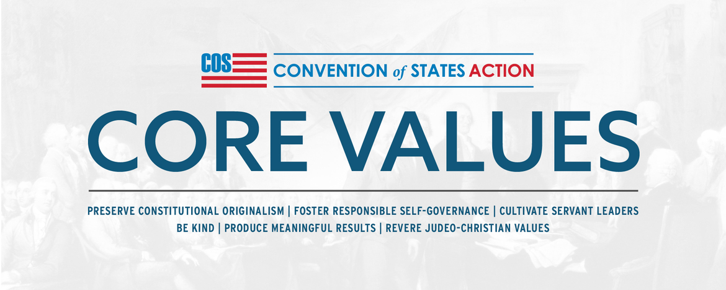

COS Core Values
To Save America, we are building a grassroots army of self-governing activists. We have united around Article V of the U.S. Constitution to tighten the boundaries on the federal government's overreach and fiscal appetite. The success of our efforts will rest on the culture of our growing organization. Our values define our culture, and we're confident you will find our Core Values consistent with the principles that built the framework of our nation and have led to its success. United we stand and divided we fall. We can do anything together.


Preserve Constitutional Originalism:
We adhere to the wisdom of the Founding Fathers as expressed in our governing documents, and to the original meaning of their language. We actively work to restore limited, constitutional government, federalism, individual rights, and America as the beacon of freedom to the World.


Foster Responsible Self-Governance:
True liberty requires personal responsibility and individual accountability. As we work toward a culture of self-governance in our country, we promote a culture in our organization that empowers everyone to take action, learn from their mistakes, and adjust their actions accordingly for the future.


Cultivate Servant Leaders:
Servant leadership inspires employees and volunteers to serve others and make a positive difference in their communities. We promote these principles through training and mentorship opportunities.


Be Kind:
We believe in the Golden Rule; we treat others the way we want to be treated. We seek to have positive interactions with others while being professional, respectful, and speaking the truth boldly and with love.


Produce Meaningful Results:
We aspire to produce a demonstrable impact on the restoration of America to its divinely inspired ideals, and the emboldening of people around the world to work for their own inalienable right to freedom.


Revere Judeo-Christian Values:
Our Republic was founded on Judeo-Christian principles, including that every individual is created in God's image and endowed by the Creator with inalienable rights. It is the duty of the government of, by, and for the People to secure those rights.

Share this page Wiki Address: https://wiki.conventionofstates.com
Convention of States Youtube Channel
Convention of States on Rumble

Sign the COS Petition, be a leader https://conventionofstates.com/take_action
Volunteer here https://conventionofstates.com/take_action/volunteer

(540)441-7227 | CONVENTIONOFSTATES.COM | Facebook.com/ConventionOfStates | Twitter.com/COSproject| Email us

