Welcome to COSDoc
COSDoc (click here)

Convention of States Project Wiki
Wiki Address: https://wiki.conventionofstates.com
This Test Wiki Address: https://wikiprod.qacos.com
(Compressed Wiki Menu for Mobile Devices)

New on the Wiki:
A Single-Subject Convention
State specific information Constitution, State House Legislative map, etc.
eBook Collection!!! Some longer documents are being converted to eBooks.
Also located on the Main menu under Documents.
COS Wiki Video Howto make the best use of the Wiki.
Miscellaneous
- Interposition, Robert Natelson, The States’ Duty to Defend Against Federal Excess: James Madison and the Methods of “Interposition”
- Faithful Delegate Laws
- CITIZEN’S POCKET GUIDE v2 2019 ed.
Post-Revolutionary Era
- Letters of the Founders These letters mostly cover James Madison's thoughts on nullification
- 1786 Annapolis Convention Proceedings and Delegate Credentials for Philadelphia The call for the Philadelphia Convention and Credentials, Commissions for the Delegates.
- Notes on Nullification - James Madison
- Our American Government - 2003 edition
This 132 page publication from the U.S. House continues to be a popular introductory guide for American citizens and those of other countries who seek a greater understanding of our heritage of democracy. The question-and-answer-format covers a broad range of topics dealing with the legislative, executive, and judicial branches of our Government as well as the electoral process and the role of political parties.
- Elementary Catechism on the Constitution of the United States (1828)
Pre-Revolutionary Era
- The Magna Carta
- English Bill of Rights - 1689
- The Charter of Liberties of Henry I of England - 1100 AD
Popular on the Wiki
- Convenient Clips of Wiki Documents Also located on the Main menu under Documents.
- COS Jefferson Statement
- DEFYING CONVENTIONAL WISDOM: THE CONSTITUTION WAS NOT THE PRODUCT OF A RUNAWAY CONVENTION
by Michael Farris JD.
- Restoring the Rule of Law - With States Leading the Way - by Governor Greg Abbott
- Whether the Second Amendment Secures an Individual Right
Share this page Wiki Address: https://wiki.conventionofstates.com
Convention of States Youtube Channel
Convention of States on Rumble

The complete Article V resource tool
Take your time to browse around the Convention of States Wiki. We hope to answer all your questions about Article V and assist the State Legislatures in their goal of reining in an out of control Federal government.
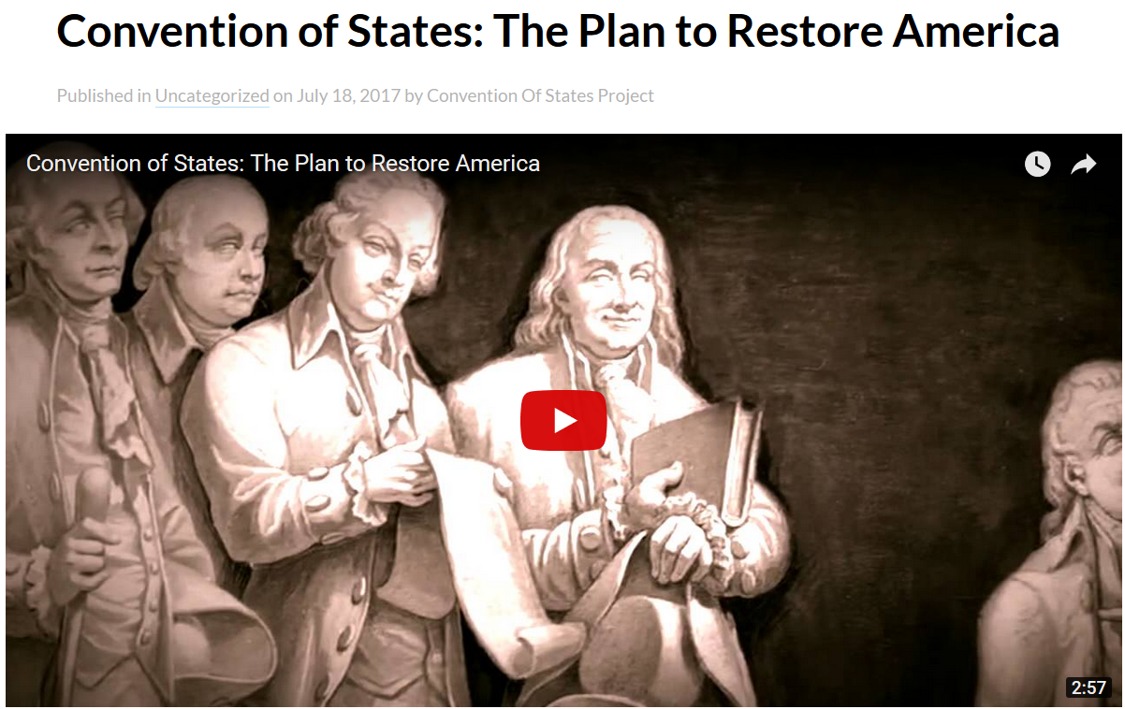
Here is the Convention of States Plan

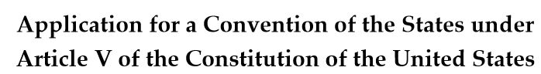
Here is the Convention of States Project Application for the Convention
Please help us to promote the Plan, and Sign the COS Petition Today! And Volunteer!


COS Classroom

Learn about Article V and Convention of States in graduated levels of study.

Blog

Convention of States Wiki Blog

Documents Library
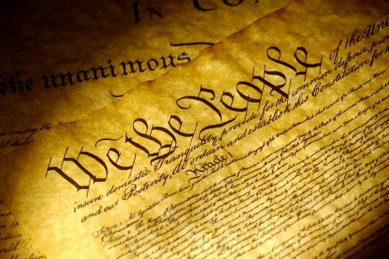

Clips
Clips of Wiki Documents

eBooks
eBook Collection

Convention of States
The following pages hold documents supporting the Convention of States Project.
– – – 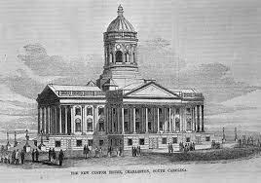
Responses To Opposition
Convention of States Project documents
Print Material
External Documents

Quotations Page
Quotations

Various Historical Documents
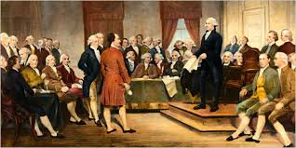
The Declaration of Independence, Constitution and Amendments, Federalist Papers, and more

Legislators Corner

Legislators Page

Social Media Links and Info

Social Media Resources

Video
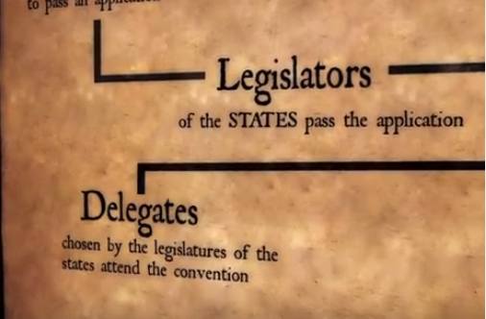
Selected Videos related to the Convention of States Project and Article V

Tags
Tag Cloud OR Tag List
Tagcloud

Help
How to use the Wiki

Wiki Help Page

Sitemap
Convention of States Project Wiki Site Map
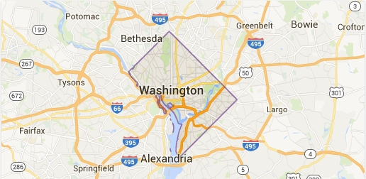Site Map

Share this page Wiki Address: https://wiki.conventionofstates.com
Convention of States Youtube Channel
Convention of States on Rumble

Sign the COS Petition, be a leader https://conventionofstates.com/take_action
Volunteer here https://conventionofstates.com/take_action/volunteer
(540)441-7227 | CONVENTIONOFSTATES.COM | Facebook.com/ConventionOfStates | Twitter.com/COSproject| Email us

Copyright / License
Copyright - license

