Introduction to COS Project
The Patriots Beginning Study of Convention of States Project and Article V
An excellent place to start are these great videos on the process.

Video

Convention of States - Now is the Time
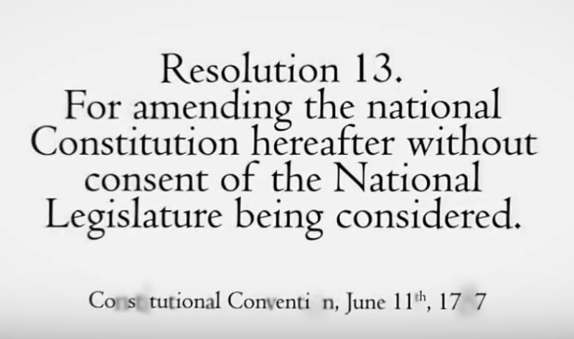
Convention of States: The Time is Now!
A brief overview of why the Framers gave us the convention mode in Article V and quotes from them and past presidents that supported this constitutional provision

Convention of States - Alabama
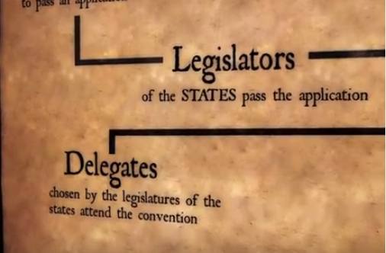
Convention of States - Alabama
An excellent video explaining the Article V process

Rise to Action

Rise to Action (Ronald Reagan)
You and I have a rendezvous with Destiny. Rise to the challenge.

Start reading here with Article V

Article V
Here is Article V
The shortest, but most important Article of the seven articles.
The Congress,
whenever two thirds of both Houses shall deem it necessary, shall propose Amendments to this Constitution,
or,
on the Application of the Legislatures of two thirds of the several States,
shall call a Convention for proposing Amendments,
which, in either Case, shall be valid to all Intents and Purposes, as Part of this Constitution, when
ratified by the Legislatures of three fourths of the several States, or by Conventions in three fourths thereof, as the one or the other Mode of Ratification may be proposed by the Congress;
Provided that no Amendment which may be made prior to the Year One thousand eight hundred and eight shall in any Manner affect the first and fourth Clauses in the Ninth Section of the first Article; and that no State, without its Consent, shall be deprived of its equal Suffrage in the Senate.

The Plan

Our Political Plan to Call a Convention of States

The Grassroots
The leadership of the COS Project believes the success of a Convention of States depends directly on American citizens. Our plan is not only simple, it is realistic:
• We will build a viable political operation that is active in at least 40 states.
• These 40 states have approximately 4,000 state house districts. Our goal is to have a viable political operation in at least 3,000 of these districts.
• We will have 3,000 district captains who will organize at least 100 people in each district to contact their state legislators to support a convention of states, and turn out at least 25 people per district at legislative hearings.
Legislators must know that our grassroots team will have their backs if they support a Convention of States. A widespread grassroots organization has been missing from the Article V movement.
CSG's President, Mark Meckler, was the co-founder of the Tea Party Patriots—the largest tea party group in the country. Michael Farris is the founder of the Home School Legal Defense Association. As such, he brings with him over 30 years of grassroots leadership and activism in all 50 states. Eric O'Keefe was the lead organizer for the term limits movement that resulted in 23 states passing ballot initiatives to that effect. We not only have experienced staff for this project, but we are also networking with like-minded coalition members across America.
The strategic advantage of a fresh start on the application process is that we will be building current grassroots operations in all of the states needed to ratify any proposed amendments, and have them all addressed at one convention. If one of the existing proposals (such as the balanced budget applications) achieved 34 valid applications, CSG certainly would support it as well. Unfortunately, the balanced budget plan relies on applications that were enacted ten, twenty, and thirty years ago. The grassroots organizations that achieved those victories are long gone. Starting fresh insures that we have current political operations in all the states necessary to actually ratify any proposed amendments.
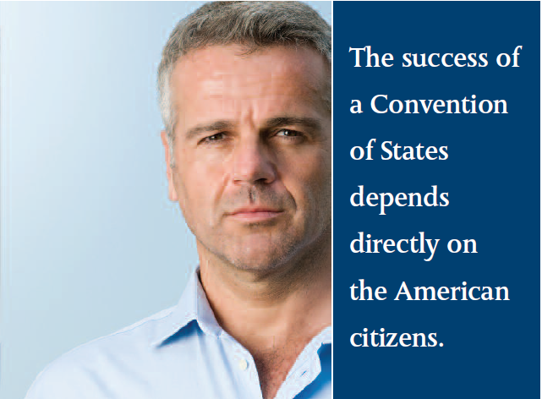
Starting fresh also allows us to avoid any legal difficulties that may arise during the “aggregation” process. Applications must deal with the same issue in order for them to be counted towards the necessary 34 states (or, in order for them to be “aggregated”). Many of the balanced budget applications, for example, are sufficiently different that they may be subject to legal challenge when the time comes to determine which states are included in the count. It is unlikely all balanced budget applications currently pending will be successfully aggregated. We will be proceeding with a unified application using the same operative language in all states.
Thus, there is both a legal advantage (clear aggregation) and a political advantage (current grassroots networking) to a fresh start on the application process. Moreover, we will have a greater ability to protect our liberty by addressing the full scope of the problems in Washington, D.C., through a Convention of States.
This unique strategy combined with strong grassroots support will provide a clear path to victory.
Only one question remains. Will you help?
http://wiki.conventionofstates.com/doku.php?id=documents:cosproject:cos_handbook#our_political_plan_to_call_a_convention_of_states

Share this page Wiki Address: https://wiki.conventionofstates.com
Convention of States Youtube Channel
Convention of States on Rumble

Sign the COS Petition, be a leader https://conventionofstates.com/take_action
Volunteer here https://conventionofstates.com/take_action/volunteer

(540)441-7227 | CONVENTIONOFSTATES.COM | Facebook.com/ConventionOfStates | Twitter.com/COSproject| Email us

